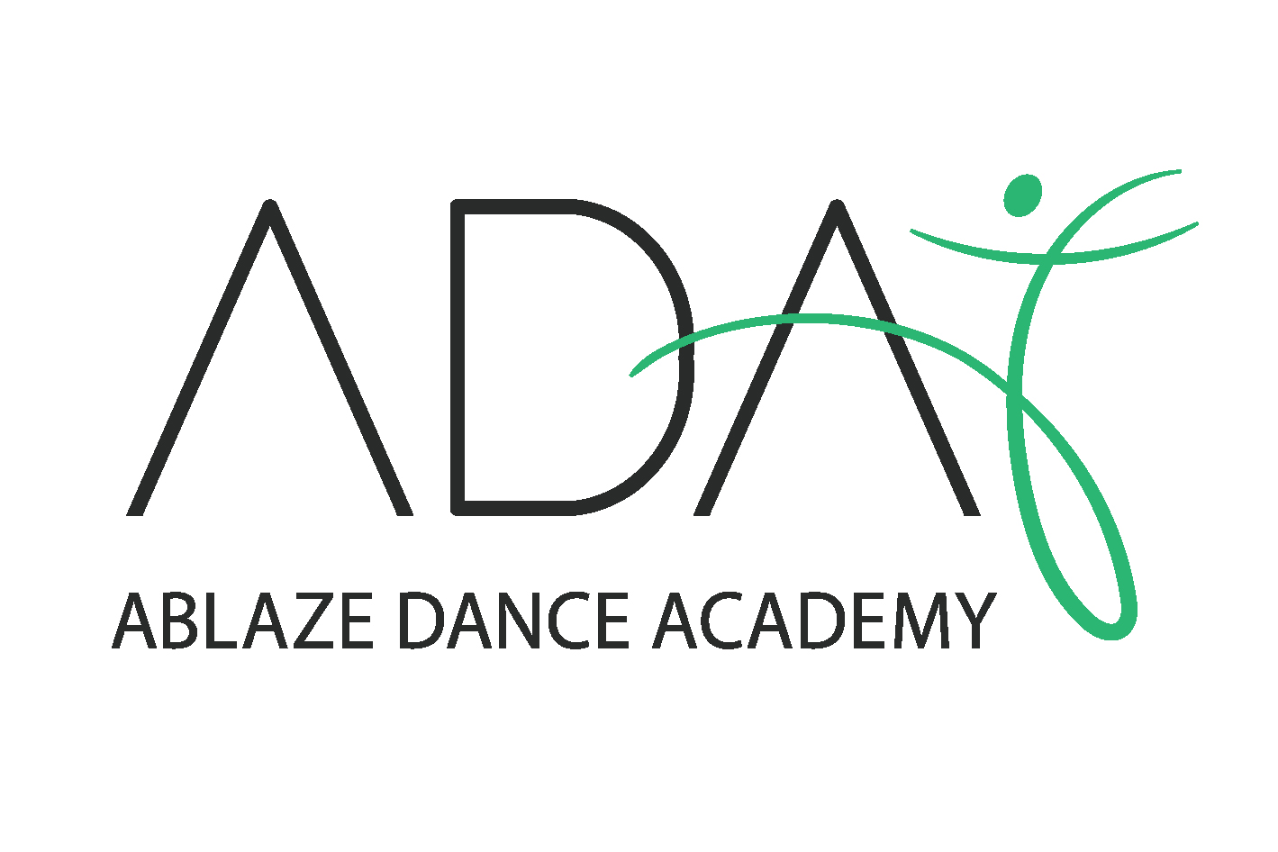
2/116 Garden Grove Parade
ADAMSTOWN HEIGHTS NSW 2289 AUSTRALIA
ABN: 53 736 480 688
EMAIL: ada.classicalcoaching@outlook.com
PH: 0437 590 054
INSTAGRAM: @ablazedanceacademy

WELCOME TO
ABLAZE DANCE ACADEMY
2021

At Ablaze we are continually striving towards the development of strong dance technique and style, incorporating exciting new choreography while providing classes and optional additional performances for all levels of performers.

We pride ourselves on our ability to cater for students of all ages and levels and continually encourage each of our dancers to achieve their potential while promoting the enjoyment of dance.
At Ablaze we believe that each and every student is unique and aim to provide tuition to suit every student’s needs and style.

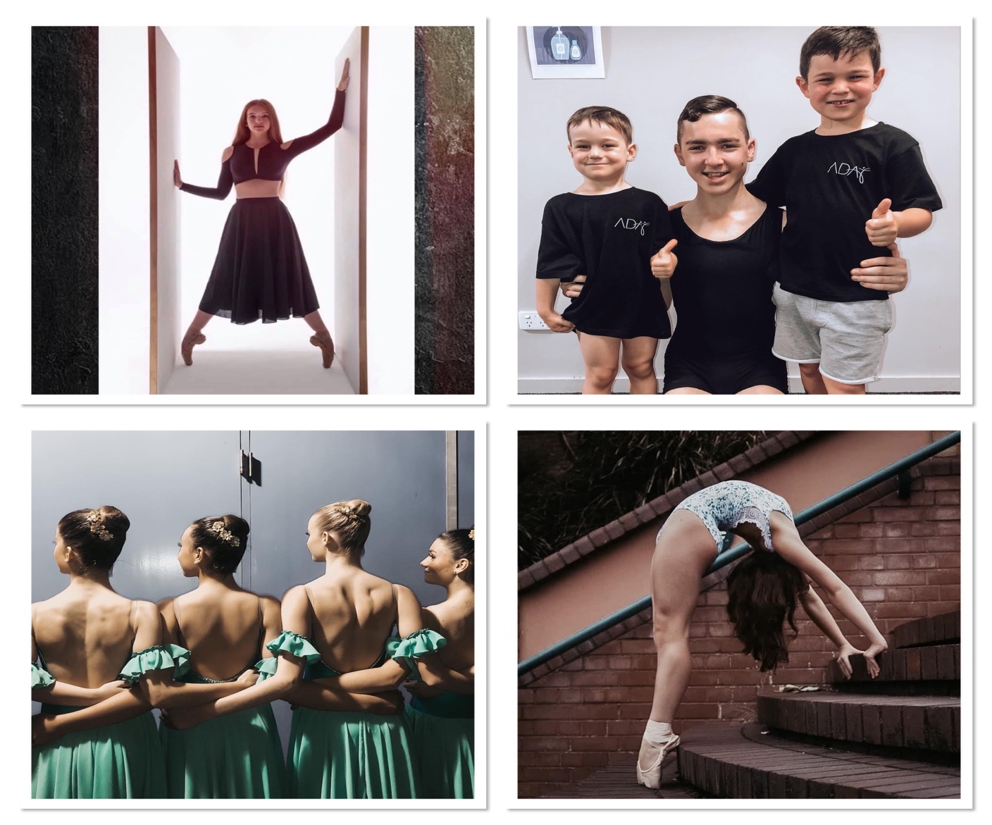

CONTENTS

- ADA Director - Bergen Lavelle…………………………4

- Dance Styles………………………………………………6

- Tiny Tots…………………………………………………..8

- Private Coaching/Solo lessons………………………….9

- Performance Teams/Competition Groups……………11

- Intensive Program……………………………………….13

- Full time & Part time courses………………………….14

- End of Year Production/Concert………………………17

- Uniform/Dress Code…………………………………….18

- Fees………………………………………………………..20

- Policies……………………………………………………22

- 2021 Registration Form…………………………………25

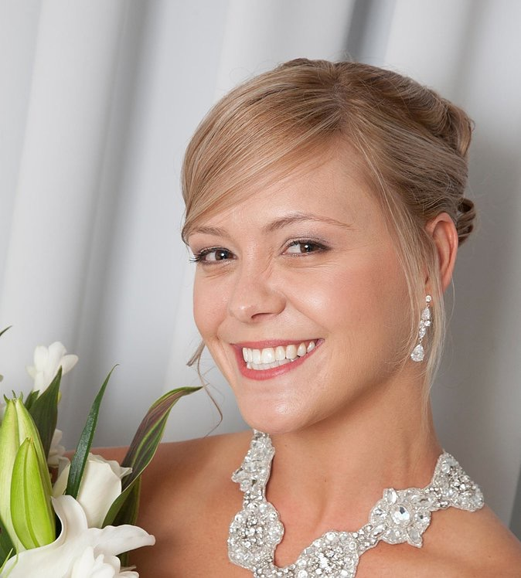
OWNER/DIRECTOR - BERGEN LAVELLE

Bergen Lavelle started dancing at the age of 3 and completed all grades within the RAD all with distinctions by the age of 9. During this time Bergen also won many championships & scholarships in many Eisteddfods.

At the age of 11 Bergen won a scholarship to attend The Australian Ballet School over the summer, hand-picked by Lisa Pavane & Greg Horsman, both of whom are Ex Principals dancers of the Australian Ballet and Ex Senior Principals of the English National Ballet.
And at age 12 was chosen by Ballet Master Anthony Shearsmith of the Queensland Ballets Company to perform with them in the season of Coppelia.

Bergen Later studied full time dancing under Marie Walton Mahon and also had coaching by Mr Edward Miller, former dancer of the Royal Ballet Company.

In this time Bergen completed all the Russian Vagonova Classical Ballet Syllabus Exams, earning an A+ for all levels, winning the Russian Vaganova Scholarship in both 1996 & 1997. This is the same year Bergen won the A.L Murphy Scholarship and was in the final 20 in the Pearl Pollard Scholarship. Bergen has also completed all levels of the Khorobushka National Character syllabus, and all RAD Exams up to Advanced before moving to Munich Germany on full scholarship to further her career by the age of 14.

While in Europe Bergen dance in many different countries including France, London, Germany and many more before moving back to Australia bringing her knowledge of dance with her.

Bergen has been teaching and passing on her passion and knowledge of dance for a number of years now and is an accredited Classical Ballet teacher with the Royal Academy of Dance completing her Diploma of Dance Teaching Studies. She is also accredited with the Australian Institute Of Classical Dance as well as the British Ballet Organisation. She is certified in Progressive Ballet Technique (PBT).

DANCE CLASSES/STYLES ON OFFER AT ABLAZE DANCE ACADEMY

RAD Classical Ballet:
Classical Ballet is the foundation for all styles of dance and it is recommended that students have training in classical ballet to further improve their posture, leg line and foot strength. Students progress through this syllabus from a pre-primary to Advanced 2 level. Examinations are available for all grades, however are not compulsory. Students wanting to complete exams participate in a minimum of 2 RAD classical classes per week. All Vocational Examination students must also take a weekly technical in addition to this.

Contemporary/Lyrical:
Contemporary/Lyrical dance is a style of expressive dance that combines elements of several dance genres including modern, jazz and classical ballet. Contemporary dancers strive to connect the mind and the body through fluid dance.

Jazz:
Jazz is a modern, dynamic style of dance, allowing students the chance to show off their unique style. Students will also learn essential jazz techniques that form the foundation of this style.

Acrobatics:
Students will learn how to conduct moves safely and correctly though guided practice with an industry professional. (Acrobatics will not perform in the end of year production)

Stretch and Strength:
This class is designed to help improve student’s flexibility and core strength which is necessary for all competition dancers

Hip Hop:
Students learn the many aspects of hip hop dancing and other tricks related to this urban style.

Musical Theatre:
Musical Theatre is a form of theatrical performance that combines song, spoken dialogue, acting and dance.

Tap:
Tap dance is a dynamic art form in which a dancer wearing shoes fitted with heel and toe taps creates audible beats through rhythmically striking the floor. Ablaze offers the LGTDA syllabus, where students are able to sit tap exams.

PBT – Progressing Ballet Technique:
PBT is an innovative program for students to understand the depth of training muscle memory in order to perfect the correct technique.

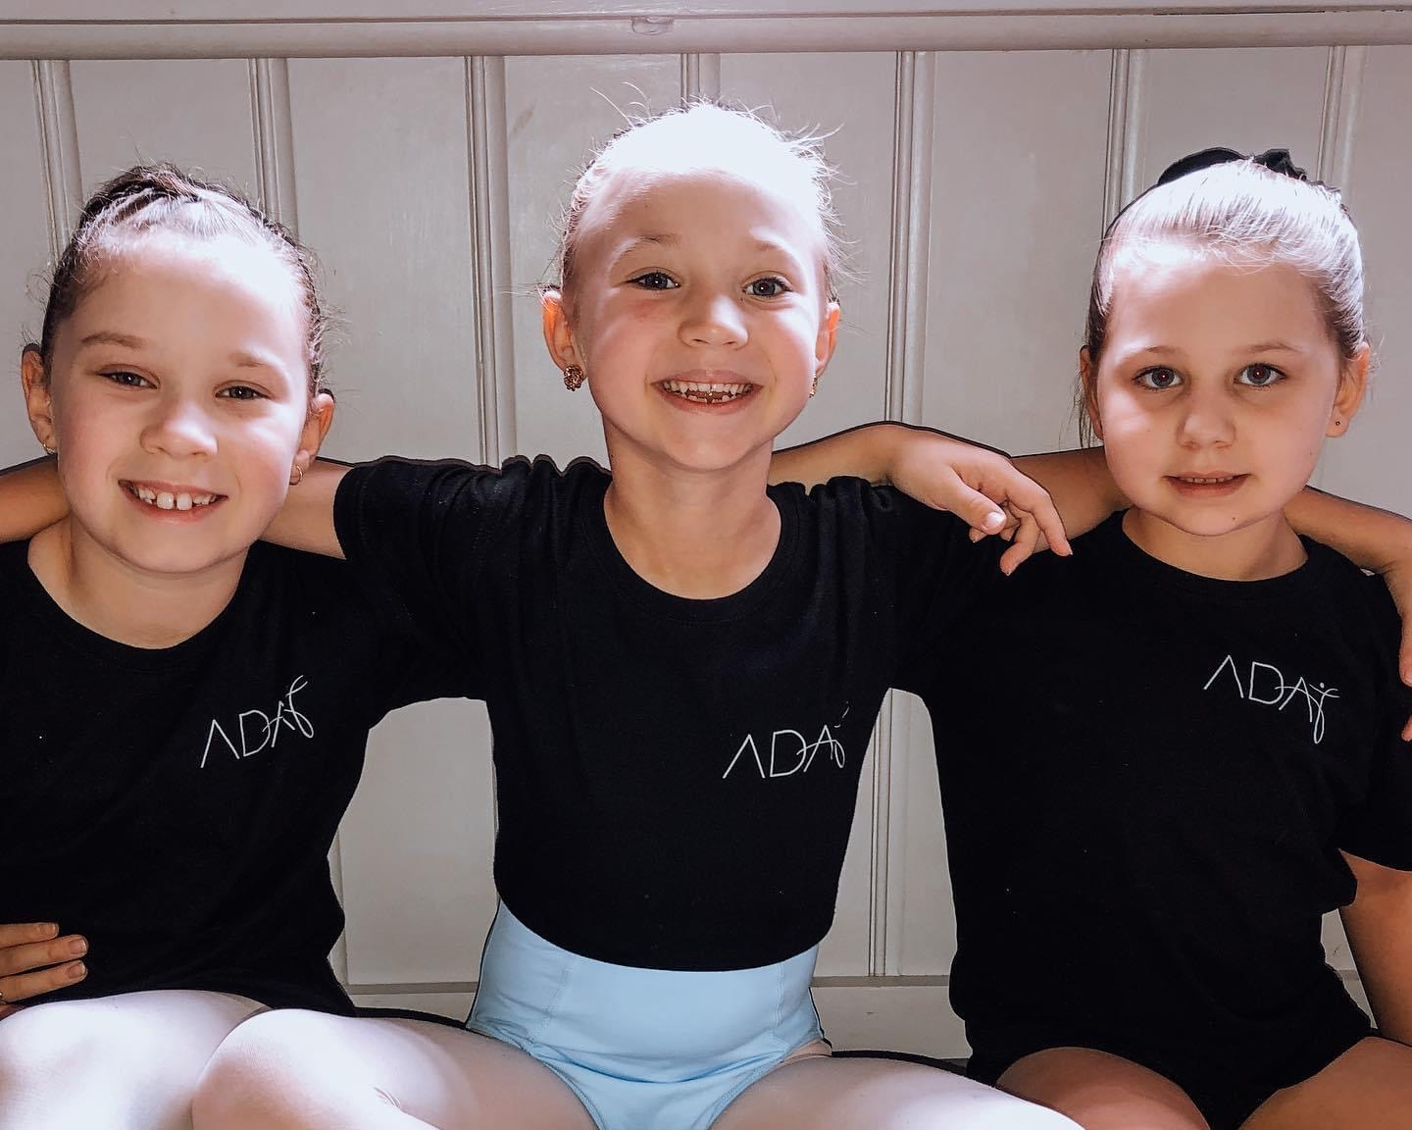

ABLAZE BABIES
TINY TOTS PROGRAM

Our Tiny Tots program caters to children from preschool - kindergarten. Classes are held during the week - offering Ballet and Jazz styles. We aim to provide a fun and caring environment where your child can explore their love of dance and music, whilst learning the basic skills and techniques appropriate to your child’s age.

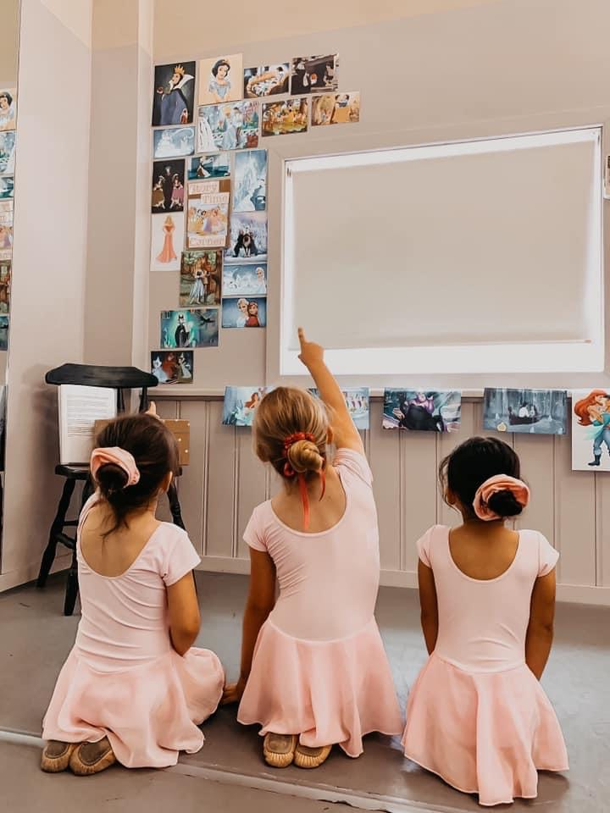

PRIVATE COACHING/SOLO LESSONS

At Ablaze Dance Academy, we offer solo coaching to students who wish to be trained one on one. Solo coaching provides a more tailored approach to training for the individual student.

Students may partake in solo coaching to:
- Perfect their classical technique in order to further excel in their Ballet Exams
- Learn and perfect solo routines in various styles to perform at eisteddfods/competitions.

Appropriate private lesson teachers & time allocations will be selected by staff. Please circle ‘Solos’ on our 2021 Registration Form and email us the type and length of lesson you would like. Please note that times are limited and fill fast.

Students wishing to have choreographed competition routines please note:
- 1/2 Private = 3 routines or less
- 1 hour Private = 3+ routines

ABLAZE SOLO COACHING POLICIES

- All choreography taught to students remains the property of Ablaze Dance Academy under ANY and ALL circumstances. If you or your child decide to attend an alternative studio students are no longer permitted to rehearse or perform the routines taught at Ablaze.
- Teachers will decide when students are ready to perform their routines on stage and parents will be notified.
- All missed private lessons MUST be paid unless a lesson is cancelled by the teacher. Lessons will then be made up when possible.
- Purchase of the Ablaze Tracksuit is compulsory and must be worn to all competitions as you are representing the studio.

PERFORMANCE TEAMS

Our performance teams/eisteddfod groups are aimed at those students wishing to compete and take their dancing to the next level. Our groups are based on the age your child is turning in 2021, and competition classes are held in addition to their weekly classes.

In 2021, our competition groups consist of Classical Ballet, Jazz, Contemporary/Lyrical and Hip Hop. In order to gain entry into our Classical Ballet and Contemporary/Lyrical groups, a minimum of two ballet classes per week is required. For our Jazz groups, a minimum of one ballet class per week is required and for Hip Hop, there are no classical ballet requirements.

If your child is participating in performance teams, a Competition Group Placement Day will be held in January before our regular classes commence. Please note, Competition groups are a year-long commitment and competitions are mostly held during school holidays and on weekends. A list of these will be emailed to parents as soon as dates have been confirmed. Separate competition classes are held each week on a Saturday to ensure appropriate training, and extra compulsory rehearsals will be called closer to each competition date as required.

To perform at a high level requires commitment from each team member, therefore we are not able to accommodate last minute changes if you or your child decides they have another commitment they would like to attend. This also applies to weekly class training. Exceptional circumstances will only be considered after a discussion with the appropriate class teacher, and children who routinely miss weekly training without due reason will be asked to reconsider their place on the team.

As competition groups are a year-long commitment and we have other team members and teaching staff to consider, fees are payable for the entire year. If your child withdraws from a troupe part way through the year, please note that you will still be liable for these fees until the end of 2021.

With our Competition Groups comes the design and creation of specially made costumes, and it is the responsibility of parents/guardians to pay for these once the invoice has been distributed. These costumes may be recalled at any time and are NOT to be used for solos or other performances/photo shoots unless circumstances require your child to do so, and ONLY with the consent of their teachers.
Please note all children will reacquire a full Ablaze tracksuit.

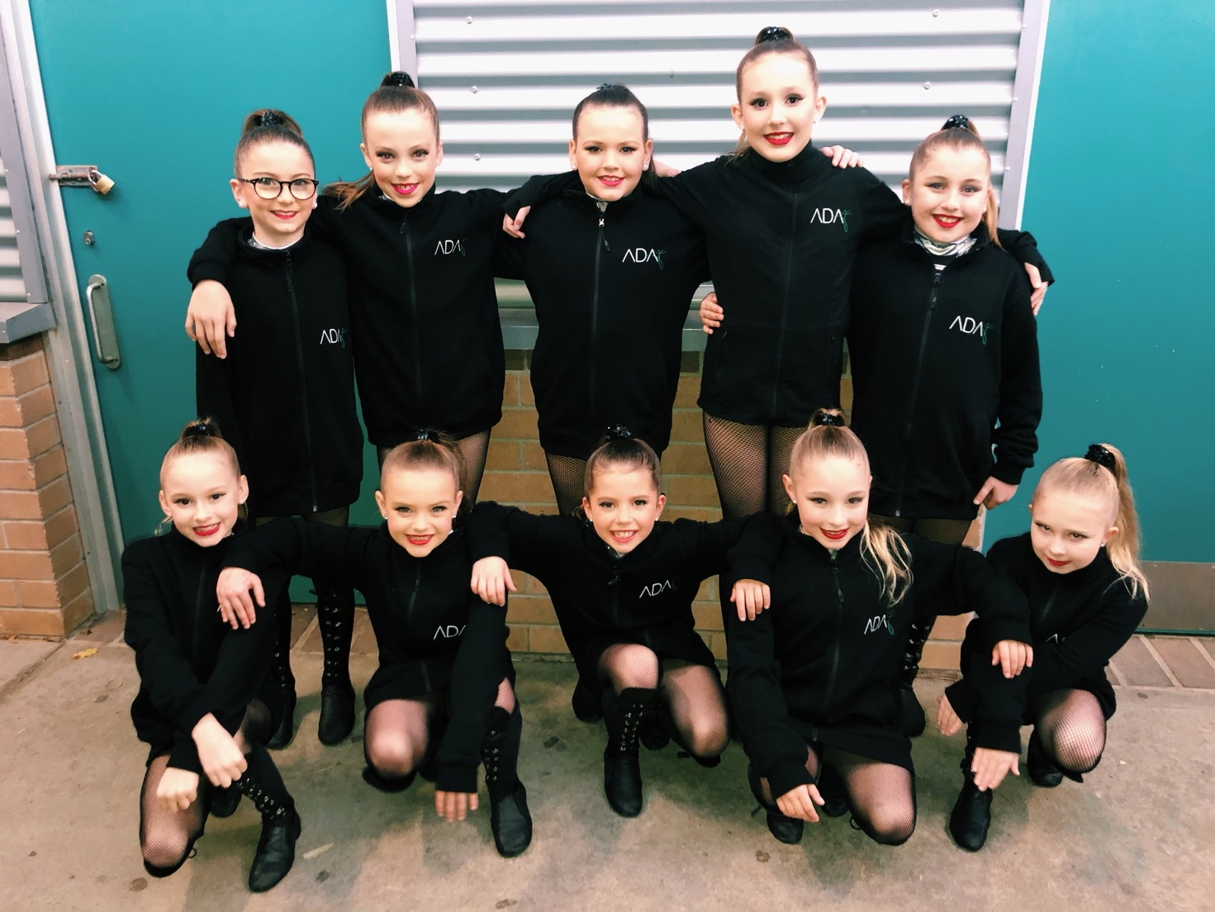

INTENSIVE PROGRAM

Our Intensive Program is designed for students who are wanting to supplement their regular training with additional classes as a replacement for their school sport. It runs on a Wednesday afternoon from 1:30pm - 3:30pm and is inclusive of Classical Ballet Open Classes and Contemporary.

This a great opportunity for your child to be involved in classes with our full and part-time students, and the level of class work is catered to these higher abilities. It is a wonderful transitional program for those considering our Bergen Lavelle Classical Coaching Full Time or Part Time programs for their future dance education.

*Cost of this program is additional to all other classes/packages.

FULL TIME & PART TIME COURSES

These courses have been developed with the aim to nurture, support and train talented young dancers in Classical Ballet and the Performing Arts. Located in Adamstown, Newcastle, New South Wales, this course provides students with access to professional and highly qualified teachers who are dedicated and committed to training and developing dancers, supporting and encouraging them to achieve their goals and reach their full potential. Also available within these courses are certificate 3 and certificate 4 in dance and dance teaching and management.

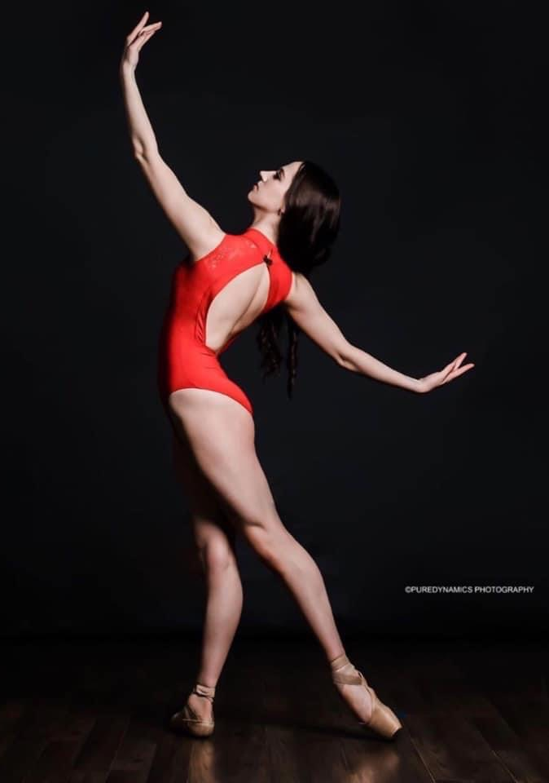
Bergen Lavelle Classical Coaching

Our Classical Ballet Full Time & Part Time Programs have been designed to advance male and female dancers considering a career in ballet.

These Programs includes:
- Classical Ballet & Open Classes
- RAD, Royal Academy of Dance Syllabus
- BBO, British Ballet Organisation Syllabus
- Pointe Work
- Repertoire & Variations
- Korobushka Syllabus (National Character)
- Contemporary
- Solo Coaching
- Body Conditioning and Stretching
- Progressing Ballet Technique (P.B.T)
- Pilates
- Fitness
- Jazz
- Nutrition

Entry into the Bergen Lavelle Classical Coaching Full Time & Part Time Courses are via private audition. Enquire now to schedule a meeting/audition and for access to our Information Booklet.

Commercial Elite Performance Course

Available as a Part Time Course, students will focus their studies on all genres of dance and performing arts. The course is aimed at preparing students for auditions leading to professional work within the dance industry.

This Program includes:
- Commercial Jazz & Heels
- Jazz Technique
- Singing
- Drama
- Musical Theatre
- Tap
- Contemporary
- Lyrical
- Hip Hop
- Acrobatics
- Solo Coaching
- Stretch & Conditioning
- Fitness
- Ballet Technique

Commercial Elite Performance Course is via private audition. Enquire now to schedule a meeting/audition and access our Information Booklet.

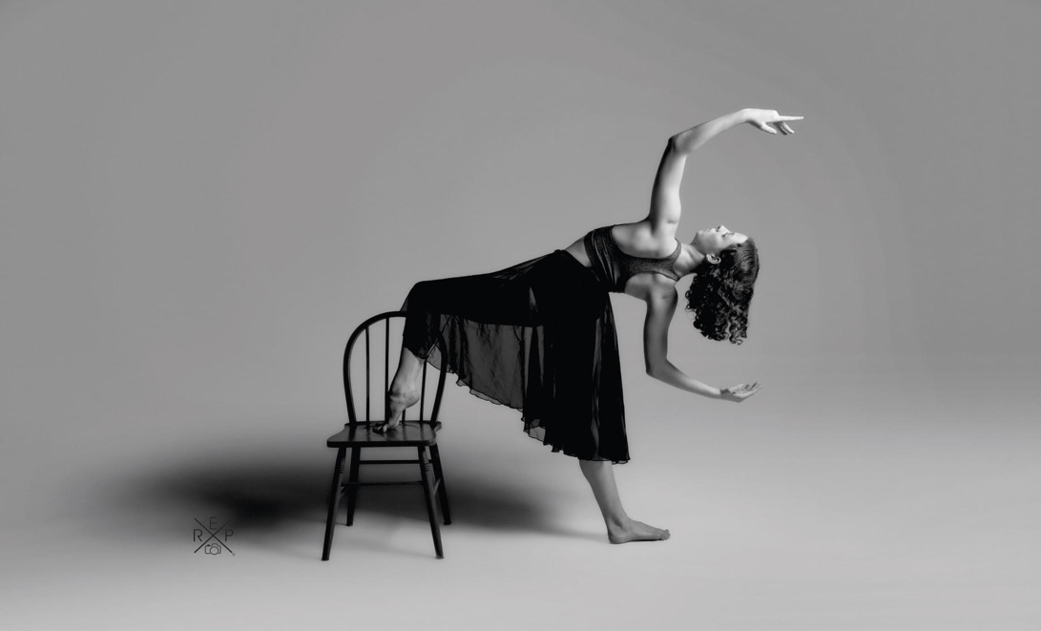

END OF YEAR PRODUCTION

Every year, Ablaze Dance Academy holds an end of year production/concert showcasing the students and what they have been learning throughout the year. This is not compulsory, however is a great experience for the children to perform and showcase their talents. It is a very exciting part of the year!

A permission note will go out in Term 3, which must be signed and returned, along a $60 costume deposit. Please understand that the concert is a commitment, and it is vital that all students wishing to be a part of the production attend all classes and rehearsals.

- $60 costume deposit to be paid with permission slip - which will then be deducted from the price of your costume invoice.
- Costume invoices will be sent via email.
- $65 set additional fee - covering all extra rehearsals, theatre costs, trophies and extras.
- A commitment to 4 Saturday rehearsals, a theatre rehearsal and the performance.

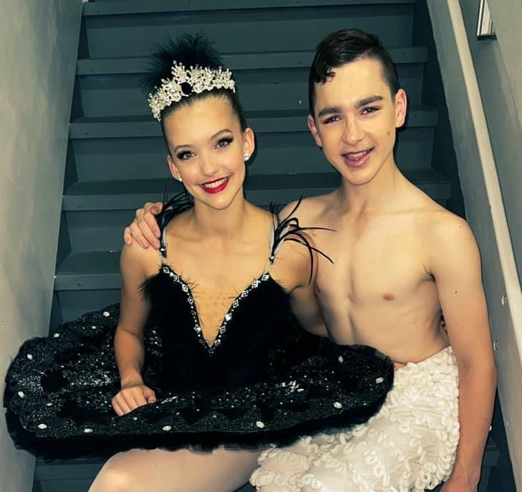

CLASS UNIFORMS

All students are required to wear the Ablaze Uniform

Hair is to be neatly tied back for all classes and placed in a bun for ballet. All fringes should be pinned back, with the exception of Tiny Tots. Matching black headbands can be worn for students with shorter hair. NO JEWELLERY is to be worn during any classes, performance or photo shoots. (Studs and sleepers are accepted).

Tiny Tots
Girls
- Pink Ballet uniform (purchased from reception)
- Pink ballet shoes
Boys
- White Tee shirt (purchased from reception)
- Black Shorts (purchased from reception)
- White Socks
- Black ballet shoes

Ballet
Female
- Black Ballet leotard
- Pink ballet stockings (theatrical pink)
- Pink Ballet shoes; Pointe shoes with ribbons
- Optional: Black Skirt (for open classes)
Male
- Black tight/all in one/shorts
- White tee shirt or leotard
- White or black socks
- White or black ballet shoes

Contemporary/Lyrical
Female
- Black Ballet leotard/Ablaze Crop top & shorts
- Bare Feet or “toe thongs”
- Black full length/footless tights (intermediate foundation and above)

Male
- Black tight/all in one/shorts
- White tee shirt or leotard
- Bare Feet or “toe thongs”

Jazz
Female
- Black leotard/ Ablaze crop top
- Ablaze shorts/ Ablaze Tights
- Black Jazz shoes
Male
- Black tight/all in one/shorts
- Ablaze tee shirt
- Black Jazz shoes

Acrobatics
Female
- Black leotard/ Ablaze crop top
- Ablaze shorts/ Ablaze Tights
- Bare Feet
Male
- Black tight/all in one/shorts
- Ablaze tee shirt
- Bare Feet

Hip Hop
Female and Male
- All black dance attire/active wear + Black Ablaze T shirt
- Sneakers

Musical Theatre

- All black dance attire/active wear – No loose baggy t shirts please.
- Chorus Heels (Senior Female)
- Jazz Shoes (Junior & Male)

ABLAZE UNIFORM

ITEM | COST
Ablaze Crop Tops | $45
Ablaze Shorts | $45
Ablaze Tracksuit | $130 - $150
Ablaze Tights | $80
Ablaze T-Shirts | $35

FEES & ACCOUNTS
*Please see Ablaze Policy for payment terms and conditions
REGISTRATION FEES 2021

Single Student Registration | $55.00
Family Registration | $75.00

CLASS FEES 2021

CLASS LENGTH | COST
30 Minutes | $9.00
2 x 30 Minute Classes | $17.00
45 Minutes | $15.00
60 Minutes | $17.00
75 Minutes | $19.00
Intensive Program | $25.00

PRIVATE LESSONS/SOLOS

CLASS LENGTH | COST
30 Minutes | $40.00
60 Minute | $75.00

PACKAGES
(No Early Discount Applies when child is on package)

TYPE | COST PER WEEK
Ultimate Junior Package  (Grade 3 and below based on ballet)  UNLIMITED CLASSES | $85
Ultimate Senior Package  (Grade 4 and up based on ballet)  UNLIMITED (after school) CLASSES  (excludes Intensive, part time and full time programs) | $95

ABLAZE DANCE ACADEMY POLICIES

All students and parent/guardians should be aware of Ablaze Dance Academy (ADA) policies before taking part in any classes.

- Many students have allergies to various foods (in particular nuts). We ask that if snacks are packed for students, they are nut free to try and eliminate potential risk.

- Students are required to attend every enrolled class, as each lesson is structured to continue the development of the student and class as a whole. All missed lessons MUST be paid for, even when notice is given.

- Fees are paid for by the Term, and students/parents who decide to discontinue their/their child’s dance training must understand that two weeks’ notice is required and that these two weeks must be paid for in full.

- All missed private lessons MUST be paid unless a lesson is cancelled by the teacher. Lessons will then be made up when possible.

- Students are required to arrive 5-10 minutes before their class to do their own mini-warm up and stretch to ensure they are ready for class. This helps to minimise the risk of injury and instill individual safe practices.

- Bullying of any sort will not be tolerated. At ADA, we pride ourselves on providing a happy, friendly environment where all students feel welcome. If you or your child has any issues in this regard, please inform our team as soon as possible so that we can work together to resolve any issues.

- ADA will communicate via many mediums, including paper notes, email and social media sites such as Facebook and Instagram. Please check these regularly to ensure you stay up to date and do not miss any important information. Parents/guardians with Facebook accounts are encouraged to join the ‘Ablaze Dance Academy Families’ group as updates are regularly posted to this page.

- ADA has a Facebook and Instagram account dedicated to studio events, news, updates and photos. Please keep all comments and posts suitable.

- All choreography taught to students remains the property of ADA under ANY and ALL circumstances. If you or your child decide to attend an alternative studio, students are no longer permitted to rehearse or perform the routines taught at Ablaze.

- ADA requires each enrolled student to complete a registration form for each year, regardless of whether they are a new or returning student. A fee for enrolment will also be charged to cover ONEMUSIC and other related costs (this fee is made clear in the fee section of this booklet). When this form is signed, you are agreeing to all Ablaze policies, terms and conditions stated on the registration form and in this booklet.

- All fees will be emailed out to families prior to the commencement of each term. If you do not provide an email address, a paper copy of your invoice will be provided.

- If fees are fully paid within the first week of the commencement of each term, a 10% Early Payment discount will apply. Please note no discounts apply if paid after first week of term. This does not apply to packages.

- All term fees must be paid for within the first 3 weeks of term or your child will not be permitted to participate in classes. Reminders will be emailed and a 10% late fee will be added. Failure to acknowledge these reminders (well overdue fees) - further action will be taken and sent to a debt collector.

- Students who set up weekly payments must show receipt of direct debit to receptionist during week 1 and must be 2 weeks in advance to be eligible for this process.

The preferred payment method is direct deposit or eftpos into the Ablaze Dance Account:

Account Name: Ablaze Dance Academy Pty Ltd
Account Number: 10318577
BSB: 062 829
REF: Invoice Number & Childs Name
If you are not able to pay via direct deposit, cash or cheque will be accepted. Cheques to be made payable to Ablaze Dance Academy Pty Ltd

- ADA holds an End of Year Concert to showcase the learnings of ALL students. Students will be required to hire/buy costumes for the concert, and also pay an additional $65 set fee.

- If you allow your child to walk home or go home with another students parent, please supply a written letter giving ADA permission to allow said child to do so.

- Ablaze Dance Academy has the following insurance cover for:
- Public Liability
- Professional Indemnity
- Workers Compensation

- All clothing and property should be labelled so it can be returned to the correct owner. All un-labelled belongings will be stored for 2 months in the ADA waiting room then donated.

- ADA requests that all mobile phones are kept in bags and out of the studio during ALL classes.

- There are limited parking places outside the ADA building. If you are not able to get a park there, please park at the top of the driveway or on the road. Please be aware of road safety and keep an eye out for students at all times.

- All students are to be presented in a neat and tidy fashion and are to adhere to the uniform guide in this booklet.

- Photographs are occasionally taken of all students. If you do not wish for your child’s photograph to appear on the ADA website/social media site/newsletter etc, please make sure you state this on the registration form.

- Smoking is prohibited on and in ADA’s grounds.

- Occasional corrections may need to be given to students, which may involve physical contact to get alignments correct or correct a certain movement; this is simply part of the industry. This is done with respect and appropriately at all times.

- All teachers and staff members hold a current Working with Children Check.

Registration Form Link:

https://www.ablazedanceacademy.com.au/copy-of-join-us

